**Online-Food Delivery Service**

Kyle D. Musegades, Jr.

Colorado State University Global

CSC400-1 Data Structures and Algorithms

Dr. Shaher Daoud

October 22, 2023

**Online-Food Delivery Service**

**Source Code:**

***Shopping Cart.java***

import java.util.Arrays;

public class ShoppingCart<MyType> implements BagInterfaceMyType<MyType> { //cart implements interface

//fields

private MyType[] myBag;

private int numberOfProducts;

private static final int DEFAULT_CAPACITY = 15; //carts default cap is 15

// constructors for myBag initialization

@SuppressWarnings("unchecked")

public ShoppingCart() {

myBag = (MyType[]) new Object[DEFAULT_CAPACITY];

numberOfProducts = 0; //starts cart with 0 products inside

}

//methods

@Override

public void add(MyType newEntry) {

myBag[numberOfProducts] = newEntry;

numberOfProducts++;

}

@Override

public int getCurrentSize() {

return numberOfProducts;

}

@Override

public MyType remove() {

MyType result = null;

if (!isEmpty()) {

result = myBag[numberOfProducts - 1];

myBag[numberOfProducts] = null;

numberOfProducts--;

}

return result;

}

@Override

public void clear() {

while (!isEmpty())

remove();

}

@Override

public MyType[] toArray() {

return Arrays.copyOf(myBag, numberOfProducts);

}

@Override

public boolean isFull() { //checks if cart is at max cap by checking length of array

return numberOfProducts >= myBag.length;

}

//main program

public static void main(String[] args) {

BagDemo(); //calls test demo

}

//BagDemo

public static void BagDemo() {

ShoppingCart<String> cartTest = new ShoppingCart<>();

// tests by adding a few new items to bag

cartTest.testAdd();

cartTest.add("Hot Dogs");

cartTest.add("Bread");

cartTest.add("Water Bottles");

cartTest.add("Chips");

cartTest.add("Milk");

cartTest.add("Soda");

// display method in demo

cartTest.displayBag();

}

//Test method

public void testAdd() {

System.out.println("Adding Items to cart");

System.out.println("--------------------------");

}

// Method to display the contents of the bag

public void displayBag() {

MyType[] data = toArray(); //to array method

System.out.println("Products currently in cart:");

for (MyType products:data) {

System.out.println(products);

}

System.out.println("--------------------------");

}

}

***BagInterfaceMyType.java***

public interface BagInterfaceMyType<MyType> {

//Implemented methods into Shopping Cart

public void add(MyType anEntry);

public int getCurrentSize();

public MyType remove();

public boolean isEmpty();

public void clear();

public MyType[] toArray();

public boolean isFull();

}

**Program Execution Screenshot**

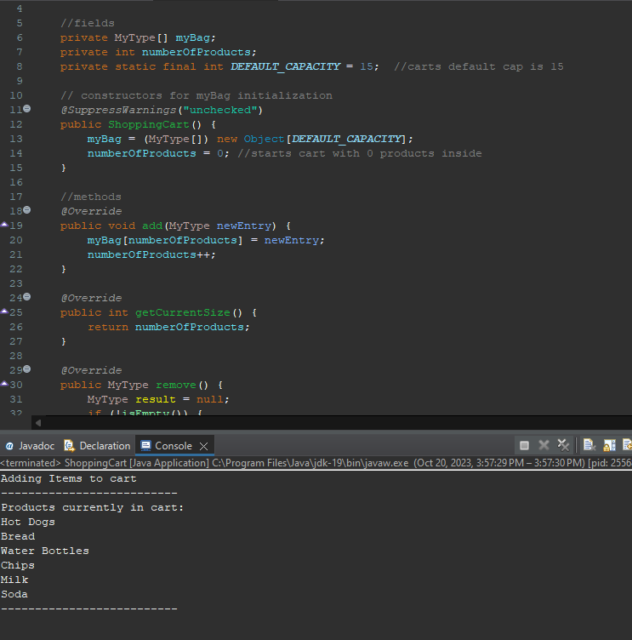

**References**

Carrano, F. M., & Henry, T. (2019). *Data structures and abstractions with Java* (5th ed.). Pearson Education, Inc.